

Foundations of Programming

Lab Assignment No. : 02

PROBLEM STATEMENT:
Write a menu driven program in C to implement the basic arithmetic operations such as Addition, Subtraction, Multiplication, and Division.

OBJECTIVES:
• To understand the concept of menu driven programming in C.
• To apply conditional statements and switch–case control structures.
• To perform basic arithmetic operations using user-defined input.
• To enhance logical thinking and problem-solving skills.

THEORY:
if–else ladder statements syntax and sample program
switch–case or if–else ladder statement syntax and sample progrM
Basic arithmetic operations include Addition, Subtraction, Multiplication, and Division. Division by zero should be avoided.

ALGORITHM:
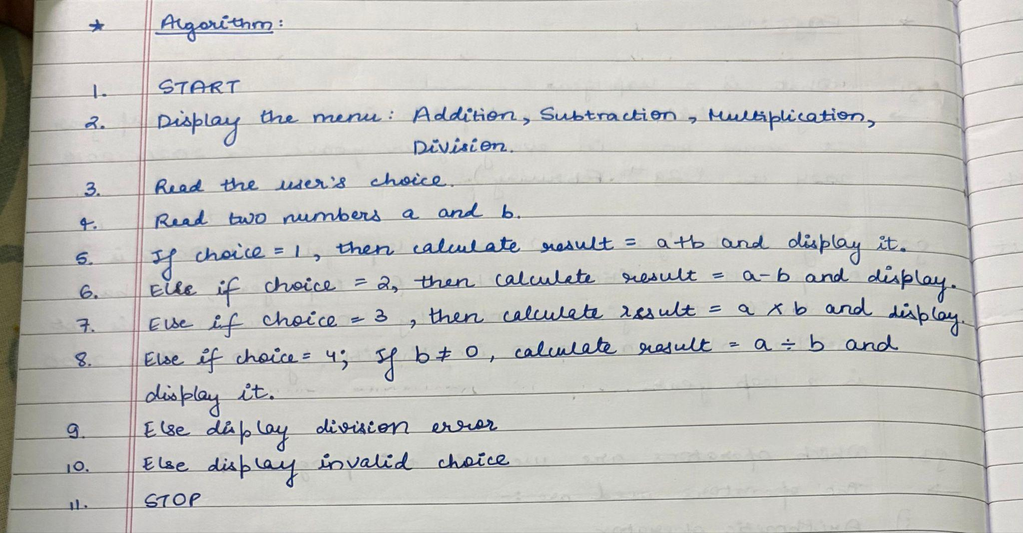

FLOWCHART:
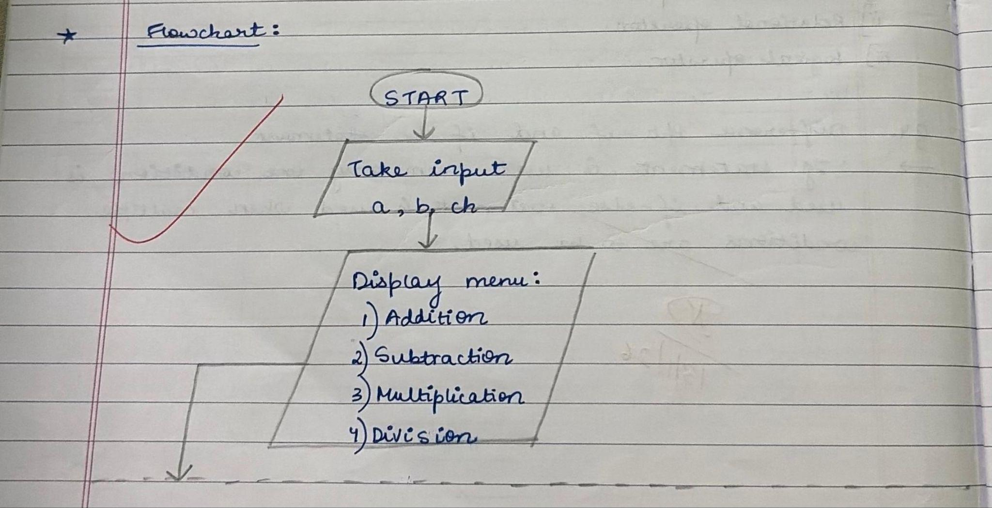
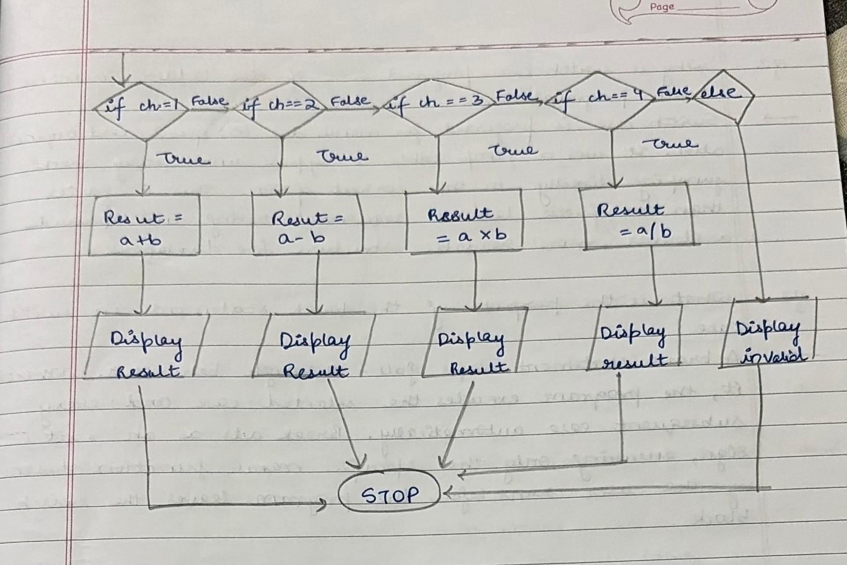
CODE:
#include <stdio.h>
int main() {
int choice;
float num1, num2, result;
do {
printf("\n--- MENU ---\n");
printf("1. Addition\n");
printf("2. Subtraction\n");
printf("3. Multiplication\n");
printf("4. Division\n");
printf("5. Exit\n");

printf("Enter your choice: ");
scanf("%d", &choice);

if (choice >= 1 && choice <= 4) {
printf("Enter two numbers: ");
scanf("%f %f", &num1, &num2);
}

switch (choice) {
case 1:
result = num1 + num2;
printf("Result = %.2f\n", result);
break;

case 2:
result = num1 - num2;
printf("Result = %.2f\n", result);
break;

case 3:
result = num1 * num2;
printf("Result = %.2f\n", result);
break;

case 4:
if (num2 != 0) {
result = num1 / num2;
printf("Result = %.2f\n", result);
} else {
printf("Error! Division by zero is not allowed.\n");
}
break;

case 5:
printf("Exiting program...\n");
break;

default:
printf("Invalid choice! Please try again.\n");
}
} while (choice != 5);
return 0;
}

PLATFORM:
Linux

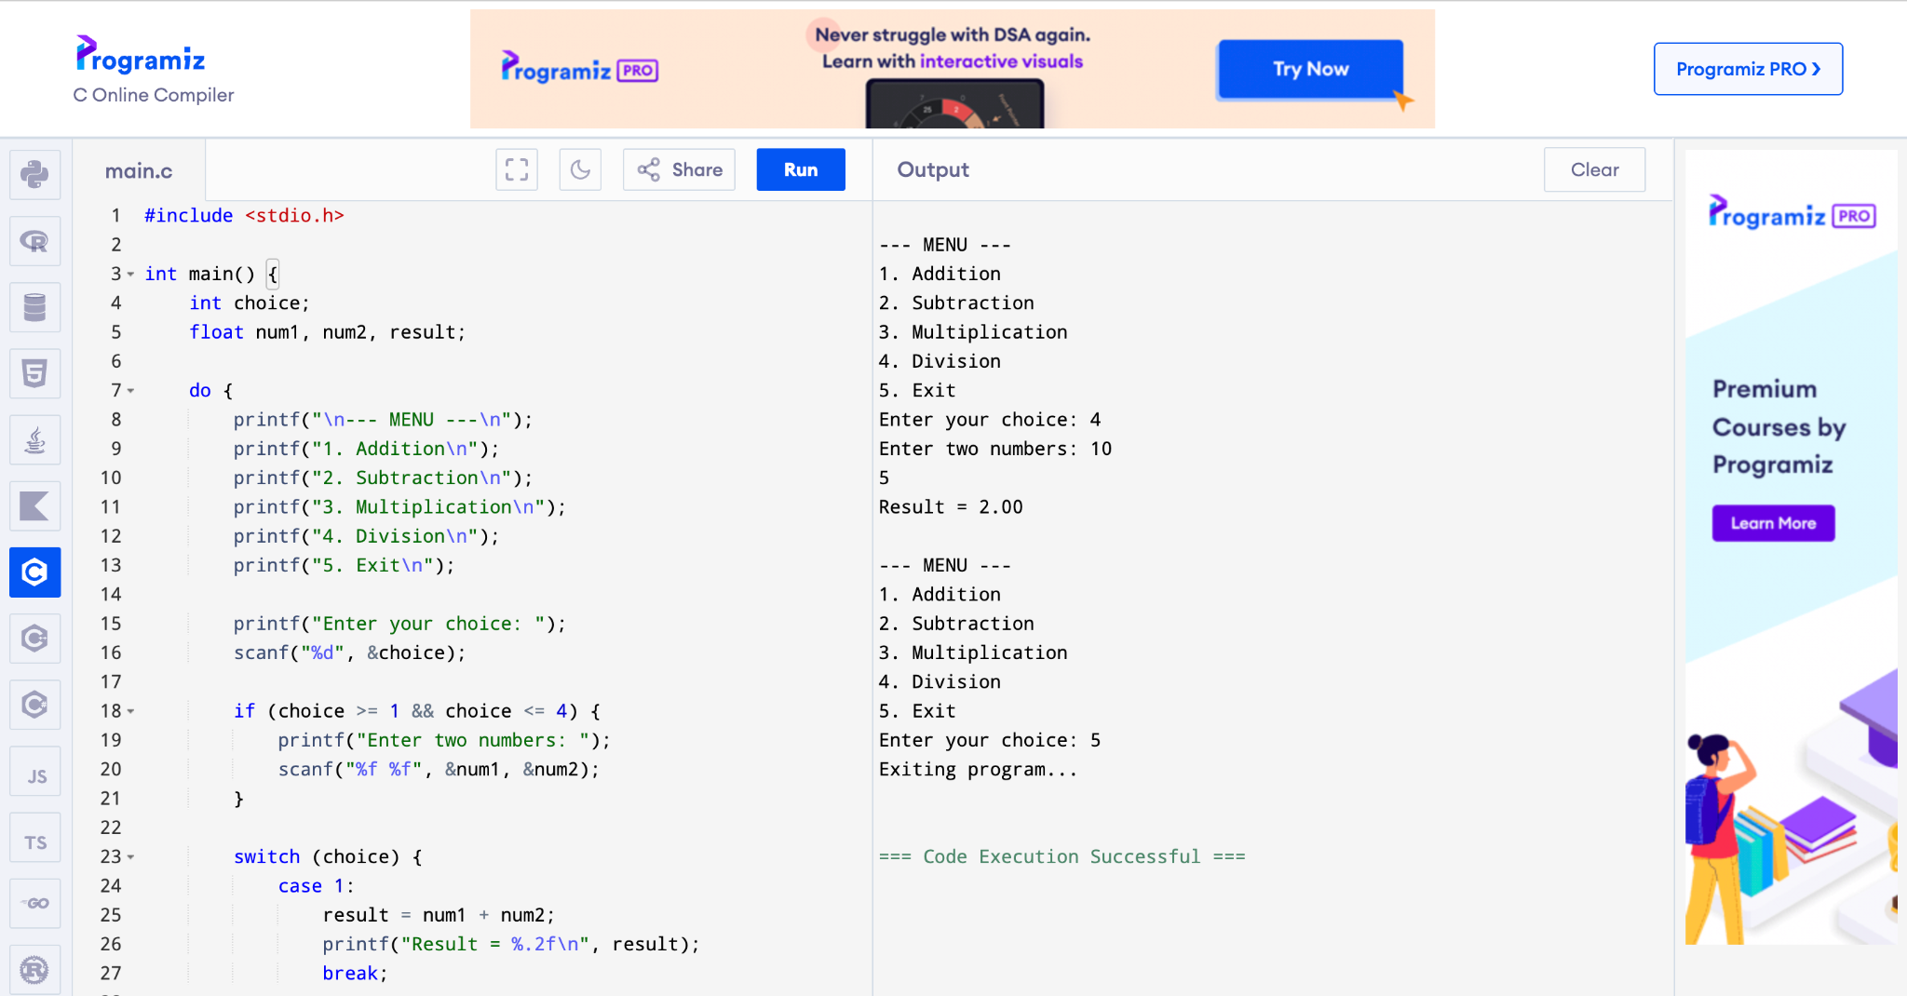

CONCLUSION:
Thus, the menu driven program in C successfully performs basic arithmetic operations using switch–case statements.

FAQs:
1. What is a menu driven program?
2. Why is switch–case preferred over if–else ladder in menu driven programs?
3. What is the purpose of the break statement in switch–case?
4. What is the purpose of the break statement in switch–case?
5. What are the limitations of switch–case compared to if–else?

